**Virtual Doctor: A System based on Learning Analytics in Healthcare**

Dr. Mukesh Gupta a\*, Tanu Shukla b and Daksh Dave c

a MBBS, M.D, Maharashtra Medical Council, Founder LeNest, Mumbai, India; b Humanities Department, BITS Pilani, Pilani, India; c Electrical Electronics Department, BITS Pilani, Pilani, India

**Acknowledgements**

We would like to express our gratitude to all those who have helped us directly or indirectly to complete this report. Firstly, we would like to express our gratitude towards the institute, Birla Institute of Technology and Science (BITS) – Pilani, Pilani Campus, for granting us this wonderful opportunity of studying and working on this interesting Design Project course under Professor Tanu Shukla.

We are deeply indebted to Dr. Mukesh Gupta and LeNest clinic for guiding us with the topic, providing the resources as well as the opportunity to work on this this report. We also thank our parents and the almighty for their blessings and grace.

**Table of Contents**

* **Abstract**
* **Introduction**
* **Literature Review**
  + **Dialogflow by Google**
  + **Agents**
  + **Intents**
  + **Dialogflow Console**
  + **Messenger Platform**
* **Methodology**
  + **Objective**
  + **Intent Creation**
  + **Testing**
  + **Training**
  + **Creating a Facebook APP**
  + **Dialogflow Messenger Integration**
  + **Website Integration**
* **Challenges and Limitations**
* **Benefits**
* **Improvements and Innovations**
* **Conclusion**
* **References**

**Virtual Doctor: A System based on Learning Analytics in Healthcare**

**Abstract-**

Health is the most important aspect of our lives. However, with an increase in the population of India and a decrease in the birth rate. The expansion of medical developments and population has gone out of synergy with the population surpassing the latter making it difficult to obtain doctor consultation. To solve this problem, we propose an AI and NLP (Natural Language Processing) based automated conversational chatbot system which can act as a virtual healthcare expert for pregnant women, family with young kids and mothers that can advise patients about the basic details and information in real-time about the problems that they are facing and reduce the workload and costs of the Healthcare industry and save and impact 100 of lives. The information provided would improve accessibility educate the users on Health resulting in a behavioral change. We concluded that automated medical products may flourish to serve a bigger role in healthcare. In the future, the chatbot can be trained to assist all doctors in providing consultation and performing surgeries by integrating all the stakeholders in the value chain of the Healthcare industry.

**Keywords:** *Learning Analytics, Chatbot, Deep Learning, Healthcare Informatics, Healthcare Communication, Pregnancy*

**Introduction-**

A chatbot is a computer program that conducts a conversation via auditory or textual methods. These programs are designed to provide a clone of how a human will chat and thereby it acts as a conversational partner rather than humans. For various practical purposes like customer service or information acquisition, the chatbot is being used in the dialog system. Most chatbots use natural language processing for interpreting the user input and generating the corresponding response but certain simpler systems search for the keyword within the text and then provide a reply based on the matching keywords or certain pattern. Today, chatbots are part of virtual assistants such as Google Assistant and are accessed via many organizations' apps, websites, and on instant messaging platforms. Non-assistant applications include chatbots used for entertainment purposes, for research, and social bots which promote a particular product, candidate, or issue.

Chatbots are such kinds of computer programs that interact with users using natural languages. For all kinds of chatbots, the flow is the same, though each chatbot is specific in its area of knowledge that is one input from the human is matched against the knowledge base of the chatbot. Chatbot’s work basically on Artificial intelligence.

So, using this capability we have decided to add some contribution to Health Informatics. The high cost of our healthcare system can often be attributed to the lack of patient engagement after they leave clinics or hospitals. Various surveys in this area have proved that that chatbot can provide healthcare in low costs and improved treatment if the doctors and the patient keep in touch after their consultation. To answer the questions of the user chatbot is used. There is a very a smaller number of chatbots in the medical field.

The proposed system provides a text-to-text conversational agent that asks the user about their health issue. The user can chat as if chatting with a human. The bot then asks the user a series of questions about their symptoms to diagnose the disease. It gives suggestions about the different symptoms to clarify the disease. Based on the reply from the user the accurate disease is found, and it suggests the doctor who needs to be consulted in case of major disease. The system remembers past responses and asks progressively more specific questions to obtain a good diagnosis. The three primary components of our system are (1) user validation and extraction of symptoms from the conversation with the user, (2) accurate mapping of extracted (and potentially ambiguous) symptoms to documented symptoms and their corresponding codes in our database, and (3) developing a personalized diagnosis as well as referring the patient to an appropriate specialist if necessary.

A healthy body relates to a healthy mind. In today’s generation, people have become busy chasing and running behind materialistic pleasures in turn forgetting about the most important necessity for their body. There is a major role of information in child and maternal health practices. And apart from these the most important fact is in the reliability and accuracy of the information that is provided as it can influence maternal health behaviors. The going-to-be mothers seek access to this information mainly through doctors. However, this is not the case with the villages that do not have the facilities, hospitals, and doctors to treat their illness or charge a hefty amount of fees that they are unable to afford. So, the proposed solution is a virtual healthcare assistant that can benefit everyone.

The to-be-mothers experience symptoms that may not require medical attention and they may experience symptoms that may require immediate medical attention. The need for proper communication with its proper delivery plays a crucial role to ensure proper health practices and save commuting costs. The maternal industry is flooded with patients that require support outside the hospital setting. It is hence necessary to have a support system that can be accessed by the patients virtually.

Families dealing with pregnancy are very particular concerning the wellbeing of their offspring and themselves making them want to adopt a healthy lifestyle change. An average appointment session with a doctor generally does not last for more than 15 minutes. Such a duration may not be enough to explain everything to a mother. So, with the development of ICT, a lot of women have resorted to searching on websites and apps on the google play store.

In the last few years, the Improvement in Hardware systems and GPUs has led to a rise in the number of Chatbots that are described by (Nadarzynski et al., 2019) as “*Natural language processing systems acting as a virtual conversational. agent mimicking human interactions.5 While this technology is still in its developmental phase, health chatbots could potentially increase access to healthcare, improve doctor-patient and clinic–patient communication, or help to manage the increasing demand for health services such as via remote testing, medication adherence monitoring, or teleconsultations.*6–8”. Using chatbots in healthcare is a part of Healthcare Informatics. Health Informatics has come out to be one of the hottest fields in the last decade, with a huge role of social media, apps, and websites in helping penetrate through the masses. However, analyzing real-time information that is accurate, reliable, specific, and covers unique cases is one of the biggest challenges that an assistant may face.

There has been a lot of criticism that the chatbot solution faces with an argument that the chatbot can never replace an on-field doctor. However, our solution is just an aid to the doctor-patient relationship by acting as a first-level point of support for the doctors and patients. Nevertheless, the main function of a chatbot of providing information remains useful almost everywhere to everyone provision of this type of assistant will make the patients aware of their health by helping them keep track of their condition with minimal human intervention and reduce stress, anxiety thus simplifying the process of Healthcare by the intervention of technology.

This research paper discussed the development, design, and need of a chatbot. All the challenges, perspectives, stakeholders, and functionalities are introduced. A quality framework has been implemented to analyze the factors influencing the adoption and development practices along-with the

necessity of a virtual doctor assistant that can be used to provide first-level support to to-be-mothers via a conversational-based support system.

The paper is further classified as follows section 2 contains the review of literature related to current developments in Health Informatics and chatbot solutions in the field of Healthcare. Section 3 discusses the method of study used. Section 4 presents the results of the output. Section 5 presents the discussions containing the interpretation and description of the significance of the findings. Section 6 provides the conclusions.

**Literature Review-**

In 1996 Chatbots were introduced and since then these agents have made countless contributions to humanity by making our lives easier. The old chatbots were just a mere question-answer automated tool where your question needed to match with the question pre-feed in the chatbot to be able to provide an answer. But nowadays the chatbot technology has rapidly advanced and FAANG companies like Amazon, Microsoft, and Google are heavily investing in the field of Natural Language Processing for text and chat-based communication which can analyze the context of the conversations to provide customized and personalized answers to different range of questions. (Kandpal et al., 2020) “*Amazon Alexa is a great example of Virtual Assistantship as it provides help in various day-to-day activities like setting alarms, listening to music, news updates, and online shopping just by speaking.*”

* **Dialogflow by Google**

A popular chatbot development tool was introduced by Google as a part of its Google Cloud Platform services. (Kandpal et al., 2020) stated that “*Dialogflow helps businesses in providing latest tech services related to the field of Cloud Computing, Databases, Machine Learning and AI. Dialogflow can analyze both voice and text-based user inputs. Dialogflow can be integrated on whichever platform the developer wants to deploy and it can interact with various devices like mobile phones, car, TV, Google home or phone calls.”*

The concept behind Dialogflow is NLU(Natural Language Understanding) which can take all the other possibilities while the user is interacting with the chatbot without requiring any hardcoding. This is achieved by certain advanced functionalities like brief summarizations, different accents, and sentiment analysis which are prefeed into the Dialogflow model and do not need external addition.

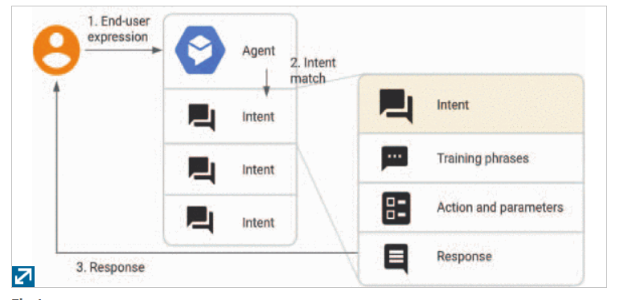

Figure1: Algorithm of DialogFlow

We mention below some common terminologies that are used by Dialogflow in its Design and Implementation.

Agents

All our conversations are handled by a virtual Dialogflow agent that can handle conversations. The agent uses NLU to interpret the user languages. Dialogflow allows us to build an agent to handle the workflow of all our system conversations and help structure the unstructured data of our text and voice inputs. The agent can be considered as analogous to a virtual assistant to the user trained to handle complex real-time conversations without requiring any explicit training.

## **Intents**

The intention of the user can be matched and defined with the help of intents. A lot of intents can be defined for each user. The combination of all these intents will help the agent in handling the entire conversation. On receiving a message, the user expression gets matched to the best-suited intent for the incoming user message categorized as intent classification.

Another important functionality of intents is that they can also be used to extract important information from the messages which can be analyzed and utilized by the system for making better and more personalized decisions. The figure given below shows how the data gets extracted from the end-user-defined expression inputs of a weather prediction query.

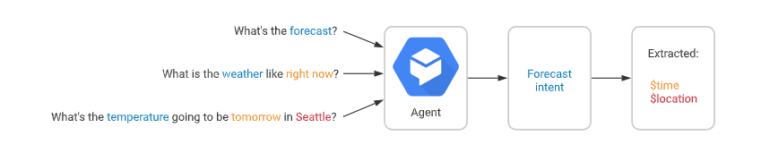

*Figure2: Data Extraction*

The following are the functionalities and modalities that a basic intent capture.

1. [*Training phrases*](https://cloud.google.com/dialogflow/docs/intents-training-phrases)*:* Dialogflow asks the developers to put in the phrases to train the model upon so that it can take those and after they are prefeed into the model use those phrases to train the model and if the users end expression is found to be resembling those phrases. The intent gets matched.
2. [*Action*](https://cloud.google.com/dialogflow/docs/intents-actions-parameters#actions)*:* Every intent can be defined with an action on getting matched with the intent Dialogflow gives us the functionality to invoke a set of actions on the system.
3. [*Parameters*](https://cloud.google.com/dialogflow/docs/intents-actions-parameters#params)*:* On getting matched with the intent some values of data can be extracted from the end-user expression known as parameters. The way the data is to be extracted gets defined by an entity type. The parameters are a set of structured data which are used to build upon the logic of an algorithm.
4. [*Responses*](https://cloud.google.com/dialogflow/docs/intents-responses)*:* Dialogflow provides us the capability of declaring the answers to the users visually as well as in the form of text and speech. The response can take in more answers by asking a question and can also terminate the conversations.

The following diagram shows the basic flow for intent matching and responding to the end-user:

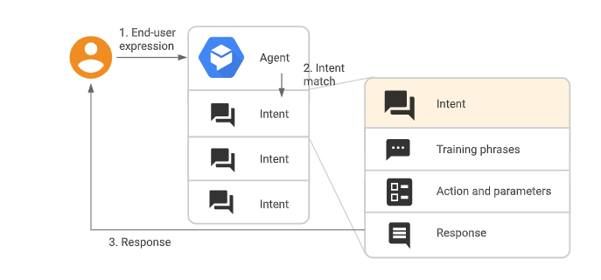

Figure3: Intent Matching

## Entities

There are entity types associated with every parameter that guides the process of data extraction from the end-user expression.

A set of system entities is provided by Dialogflow for matching the common data types with an option of creating custom entities as well for matching with the custom fed data.

## Contexts

Just as we try to get the context of conversation while talking to each other in a similar way Dialogflow takes the contexts for handling the end-user expression for matching it to the optimal intent by analyzing the context.

Contexts are very powerful tools that influence the flow of a conversation. Contexts can be configured with the help of input-output contexts, generally categorized by the name of the strings. An intent context immediately gets activated on getting matched with the intent. Dialogflow directly matches the active input contexts with the matched intents configured input contexts.

The diagram given below gives an example of the usage of context for a banking agent.

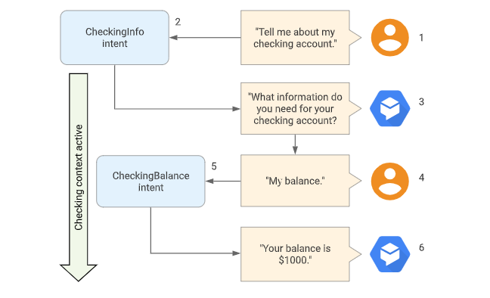

Figure4-Usage of contexts by Banking Agents

The workflow of the above diagram described by (Gelfenbeyn et al., 2018) is as follows:

1. *“The end-user asks for information about their checking account.*
2. *Dialogflow matches this end-user expression to the CheckingInfo intent. This intent has a checking output context, so that context becomes active.*
3. *The agent asks the end-user for the type of information they want about their checking account.*
4. *The end-user responds with "my balance".*
5. *Dialogflow matches this end-user expression to the CheckingBalance intent. This intent has a checking input context, which needs to be active to match this intent. A similar SavingsBalance intent may also exist for matching the same end-user expression when a savings context is active.*
6. *After your system performs the necessary database queries, the agent responds with the checking account balance.”*

## Follow-up intents

To automatically set contexts for the intents Dialogflow provides us with the functionality of follow-up intents that are the sub-branches of the parent intents. An output context gets added to the creation of a follow-up intent. The matching of the follow-up intent is done only after the matching of the parent intent. The follow-up intents can be used to guide the workflow of the algorithm with the help of nesting and by the creation of multiple levels.

A functionality of pre-defined follow-up intents is provided by Dialogflow for common replies. However, the platform also provides us with the ability to create our follow-up intents to take care of the custom replies.

# **Messenger Platform**

# Introduction to the Messenger Platform

*Working on the messenger platform:* On receiving a message from the user on the Facebook page messenger. The Facebook app is used to automate the conversations. It employs the usage of webhooks to the server URL of the business on which the app is hosted. Send API is employed to send the response to the person. The developers build conversations using the automated app flow to bridge the messenger and the agent’s presence.

The Messenger platform is provided free of cost to the customers to help businesses handle customer inquiries.

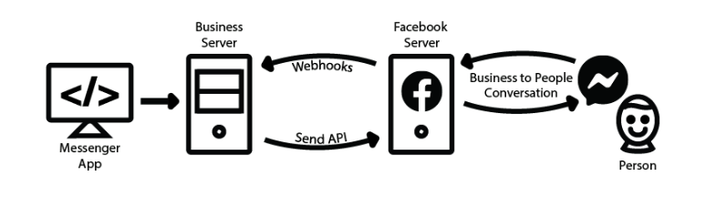

Figure6-Messenger App Workflow

There are 2 types of chatbots that we encounter: Conversational and Task-oriented chatbots. The scope of the activity of these types of chatbots is limited and there are a certain set of pre-defined rules that need to be followed. Whereas conversational chatbots rely on the usage of Deep Learning algorithms and NLP for taking the information context with a response tailored to the specific input. These types of bots also rely on Artificial Intelligence to improve the accuracy of their responses. So, it is recommended to have a chatbot to handle general conversation just like a natural conversation proceeds.

# The chatbot uses the input data of the users to interpret, parse and extract the information. The 2 classes which are statistical and rule-based use NLP systems that are text-specific ML-based statistical models and parse through the sentences, phrases, and grammar seamlessly.

# Certain high-quality practices should be maintained while designing an agent to meet the objectives of the proprietor.

### Objective

The first step is to lay out the objectives that the agent will achieve.

### Platform

The next step is to determine the platform through which the agent will be accessed by the users. The choice of the platform would play a crucial role in determining the content and the support that would be provided.

### Build agents iteratively.

The development process is a never-ending process. However, we can start by building a basic structure that provides the basic functionalities then switch onto a more complex structure with added features and functionalities. This can be done by iterating on all the possible routes of the conversation path of a user.

### Pre-built agents

Certain pre-made agents save the developers from the hassle of creating and designing the agent from scratch. Most of the common queries are covered with the help of intents and entities that contains most of the common queries of the users. The only step that this requires is to add responses to build an agent that is functioning well.

### System entities

During the process of making a request, there are important information called entities. Dialogflow provides pre-built options on these in the form of system entities.

### Small talk

During the development, it may happen in rare cases that the user may be expecting a little off-topic conversation from the agent. This type of feature can be provided with the help of the small talk option. This feature would help the agent to respond to the conversation as naturally as a human by responding to the questions related to the agent as well as provide emotional responses. There is further an option of customizing these small talk responses to suit the brand in a much better way through customization.

In this research the primary goal is to have a chatbot solution for supporting pregnant women and be their virtual companions during pregnancy by answering to their requirements and needs related to the disease of concern, suggesting preventive measures, guiding them to live a healthy lifestyle, etc.

The chatbot benefits the mothers, families, and pregnant women with young children the most. It provides different information by starting from a general to a specific set of pathway questions. The chatbot proposed an intelligent agent that represents a virtual healthcare expert and answers the queries of the users remotely from anywhere without getting affected by the geographical location of the user. These types of systems are very critical when it comes to deployment as they require accuracy and robustness.

**Methodology/Design/Implementation-**

The objectives that we plan to achieve with a chatbot are listed down.

**Objectives**

* Use Dialogflow to build a conversational chatbot that can respond to questions about the pregnancy of to-be-mothers.
* Integrate your Dialogflow model with Facebook by building a Messenger App-based web frontend for a text-chat style interface.

## For the development of the model, there was a prerequisite knowledge of using Dialogflow concepts that were needed. The following courses offered by Coursera and Qwiklabs respectively were completed before starting with the development.

* [Building Conversational Experiences with Dialogflow](https://www.coursera.org/learn/conversational-experiences-dialogflow)
* [Implementing an AI Chatbot with Dialogflow](https://google.qwiklabs.com/focuses/634?parent=catalog)

As a first step, we created a Google Cloud project and enabled all the APIs, Cloud Storage, Datastore, Compute Engine, and Repositories of Cloud Source.

## Creating a chatbot agent

We created a knowledge base for our model and a flowchart algorithm to get a rough idea of the workflow of the agent. After this, we started building the Dialogflow agent

Create a topic entity

We then created an entity that could take into consideration all the pregnancy topics that the chatbot could discuss.

### Create a chatbot intent.

We then create a chatbot intent that captures the request and gives the interaction response.

An example, of an intent modeled for interaction, is:

* User: "Hi, I am pregnant."

This question activates the HR manual intent.

* Chatbot: "OK, I'd be happy to help with that. What assistance can I provide?"

To create a chatbot intent: The procedure given below is followed

### Default intents

When you create an agent, two [default intents](https://cloud.google.com/dialogflow/docs/intents-default) are created for you:

* **Default Welcome Intent**: This intent is matched when the end-user begins a conversation with your agent. This intent should return a response that lets the end-user know what your agent does or what they can say to begin a conversation.
* **Default Fallback Intent**: This intent is matched when the agent cannot match the end-user expression to any other intent.

To see these intents, “*go to the intent list for your agent:*

1. *Go to the*[Dialogflow ES Console](https://dialogflow.cloud.google.com/" \t "_blank)*.*
2. *Select the agent you just created.*
3. *Click****Intents****in the left sidebar menu.*

*The middle of*[*the console*](https://cloud.google.com/dialogflow/docs/console)*shows the list of intents for the agent.”*

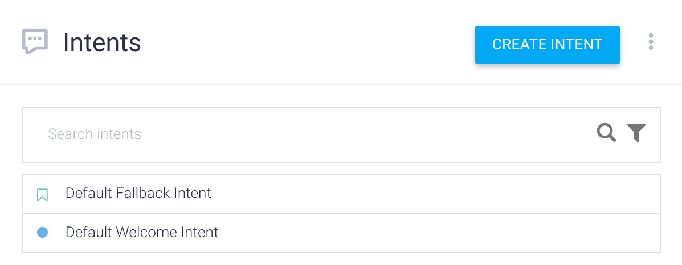

### Figure7- Default Intents

### *Simulator screenshotTest the Default Fallback Intent*

*Figure8- Intent Testing Console*

*The Dialogflow simulator is on the right side of the console. With the simulator, you can test your agent by speaking or typing messages.*

*Try the agent now:*

* *Click the****Try it now****field.*
* *Type What is your name?.*
* *Press enter.*

*The agent's response appears in the****Default Response****section. Since your input didn't match any intent, the Default Fallback Intent was matched, and you received one of the default replies.*

### *Create a new intent*

*The steps in this section create an intent that can answer the question "what is your name?". For each intent, you define many*[*training phrases*](https://cloud.google.com/dialogflow/docs/intents-training-phrases)*. A training phrase is an example of what an end-user might type or say to your agent, also known as an*end-user expression*. You should define many training phrases that provide Dialogflow with a variety of expressions that should match an intent.*

*Create an intent:*

1. *Click the add intent add button next to****Intents****in the left sidebar menu.*
2. *Enter get-agent-name in the****Intent name****field.*
3. *In the****Training Phrases****section, click****Add training phrases****.*
4. *Enter the following training phrases, pressing enter after each entry:*
   * *What is your name?*
   * *Do you have a name?*
   * *Tell me your name?*

*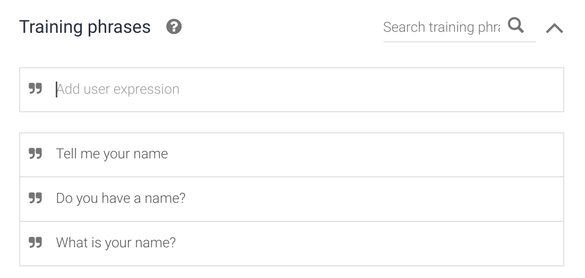*

**Figure9-Training Phrases**

***Note:****In most cases, you should enter at least 10-20 (depending on the complexity of intent) training phrases for reliable intent matching.*

1. *In the****Responses****section, enter the following in the****Text Response****section:*
   * *My name is Dialogflow!*

*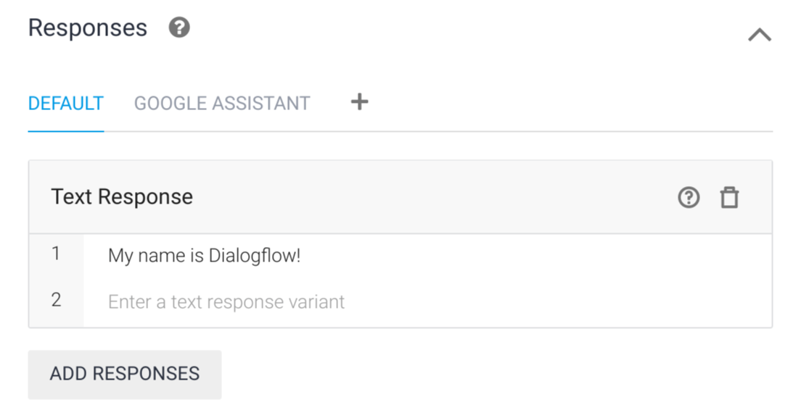*

Figure10-Add Responses Textbox

1. *Click the****Save****button and wait until the****Agent Training****dialog indicates that training is complete.*

### *Test your intent.*

*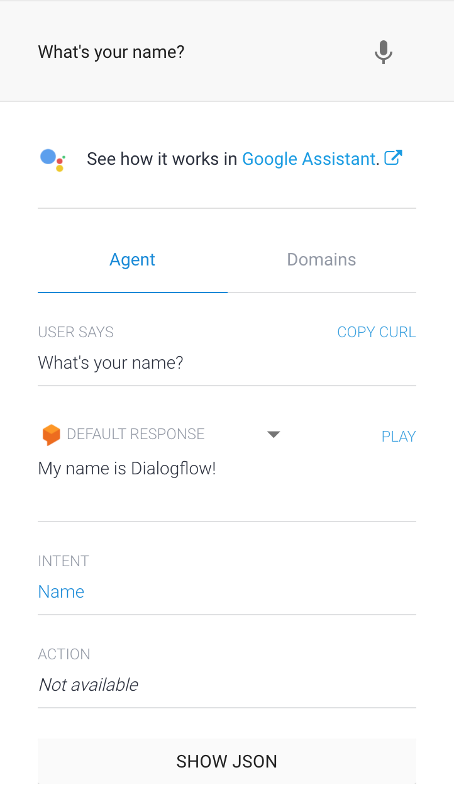*

Figure11- Dialogflow Chat ssimulator

*In the simulator, type What's your name? and press enter.*

*Your agent responds to the expression correctly, even though the expression was a little different from the training phrases you supplied.*

*Dialogflow uses training phrases as examples for a machine learning model to match end-user expressions to intents. The model checks the expression against every intent in the agent, gives every intent a score, and the highest-scoring intent is matched. If the highest-scoring intent has a very low score, the fallback intent is matched.*

## *Parameters and entities*

*When an intent is matched at runtime, Dialogflow provides the extracted values from the end-user expression as*[*parameters*](https://cloud.google.com/dialogflow/docs/intents-actions-parameters#params)*. Each parameter has a type, called the*[*entity type*](https://cloud.google.com/dialogflow/docs/entities-overview)*, which dictates exactly how the data is extracted. Unlike raw end-user input, parameters are structured data that can easily be used to perform some logic or generate responses.*

*When building an agent, you control how data is extracted by*[*annotating parts of your training phrases*](https://cloud.google.com/dialogflow/docs/intents-training-phrases#annotation)*and configuring the associated parameters.*

### *Create Parameters*

Create a new intent with parameters:

1. Click the plus add button next to **Intents** in the left sidebar menu.
2. Name the intent EPC-Down Syndrome at the top of the intent form.
3. Add the following training phrases:
   * Genetic Disorder
   * Trisomy 21
   * Downs Syndrome
4. Click the **Save** button and wait until the **Agent Training** dialog indicates that training is complete. 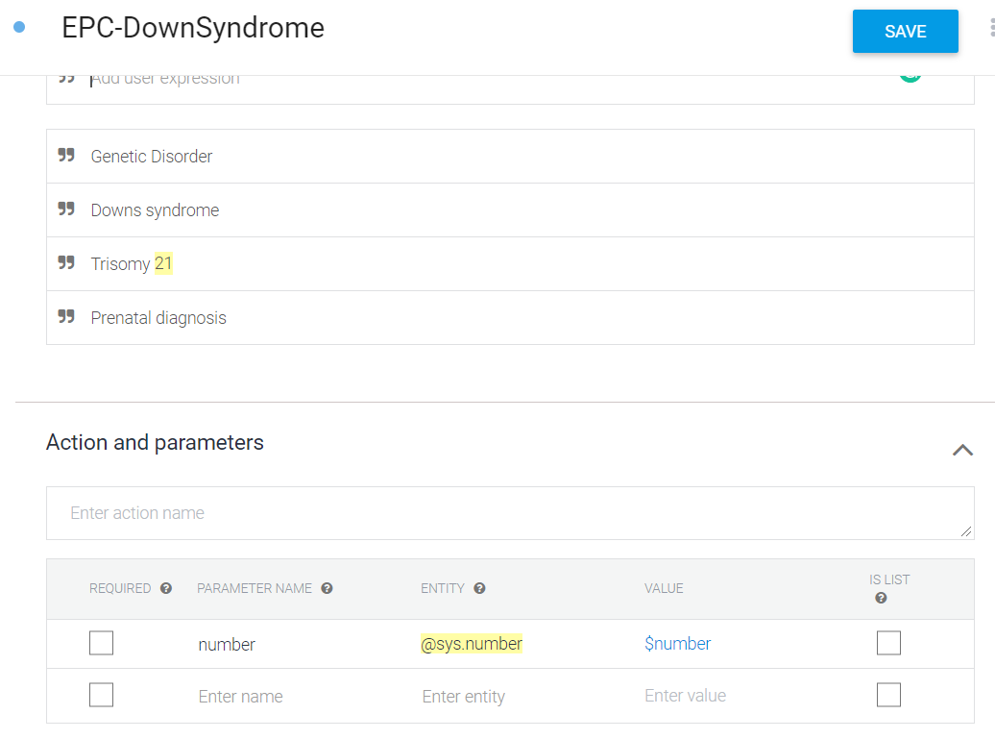

Figure12-Early Pregnancy Care Down Syndrome intent

1. Dialogflow automatically detects parameters in training phrases that are recognized as [system entities](https://cloud.google.com/dialogflow/docs/entities-system). These are entities provided by Dialogflow for many common data types like location, color, and date.

**Note:** If your training phrases are not automatically annotated, you can [manually annotate them](https://cloud.google.com/dialogflow/docs/intents-training-phrases#annotation).

Below the **Training phrases** section, Dialogflow creates a row in the **Action & parameters** table:



**Figure13-Actions and Parameters**

**Required:** The checkbox is not checked, so this parameter is optional.

* **Parameter Name:** This parameter is automatically named as a number because the parameter is recognized as a language.
* **Entity:** This is the entity type. It is recognized as a @sys.number system entity.
* **Value:** This is the identifier you use when referencing the value of this parameter.
* **Is List:** The checkbox is not checked, so the parameter is not a list.

**Note:** If entities aren't automatically detected, you can highlight text in the training phrase and [manually annotate the entity](https://cloud.google.com/dialogflow/docs/intents-manage#annotate_training_phrases).

### Use parameter data in a response

The value of a parameter can be used in your responses. For example, you can use the $number parameter reference in your responses when building an agent. At runtime, it will be replaced with the language specified in the end-user expression.

Add a response that uses a parameter:

1. Scroll down to the **Responses** section.
2. Add the following text response: Wow! I didn't know you are $number years old.
3. Click the **Save** button and wait until the **Agent Training** dialog indicates that training is complete.

### Test your parameter

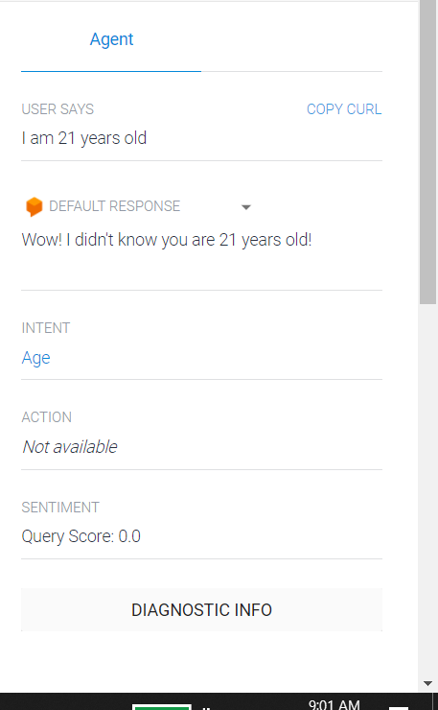

Figure14-Testing Action and Parameters

In the simulator, enter I am 21 years old.

You can see that Dialogflow correctly extracts the age parameter with the value 21, and 21 was correctly inserted where the parameter reference was used in the response.

### Create your own entities.

In most cases, you have specific data you need to gather from users that is not provided by system entities. You can create [custom entities](https://cloud.google.com/dialogflow/docs/entities-custom) to handle this.

Create a custom entity:

1. Click the add entity add button next to **Entities** in the left sidebar menu.
2. Enter language-programming for the name of the entity.
3. Add the following entity entries (rows):

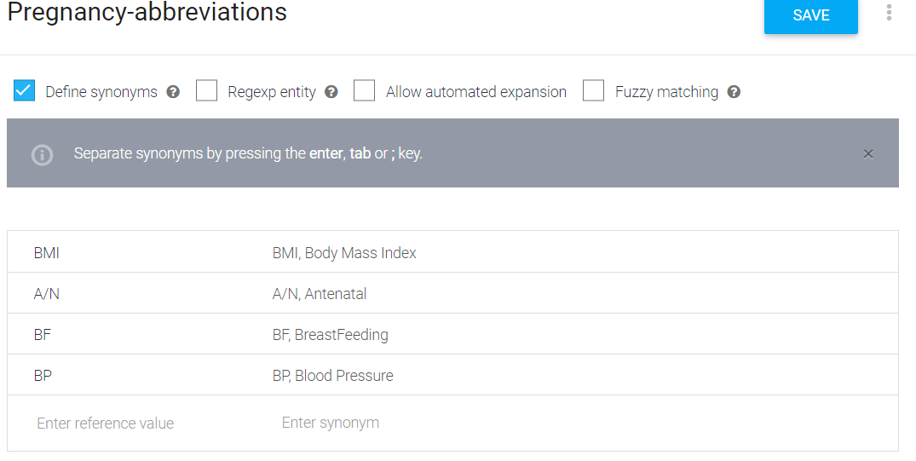

Figure15-Entity Creation

Click the **Save** button and wait until the **Agent Training** dialog indicates that training is complete. Dialogflow can handle simple things like plurality and capitalization, but you should add all possible synonyms for your entries. The more you add, the better your agent can determine your entities.

### 

### Figure16-Table of abbreviations, entities, action, and parameters

### Use your new entity

Add training phrases to the Measure intent that make use of the new entity:

1. Click **Intents** in the left sidebar menu.
2. Click the Measure intent.
3. Add the following training phrases:
   * My BP is 101
   * My BMI is 10
4. Notice that the programming languages in these training phrases are automatically annotated and added to parameters in the **Action and Parameters** section.
5. In the **Responses** section, add the following second text response: Your $pregnancy-abbreviations is $number.
6. Click the **Save** button and wait until the **Agent Training** dialog indicates that training is complete.

### Test your new entity

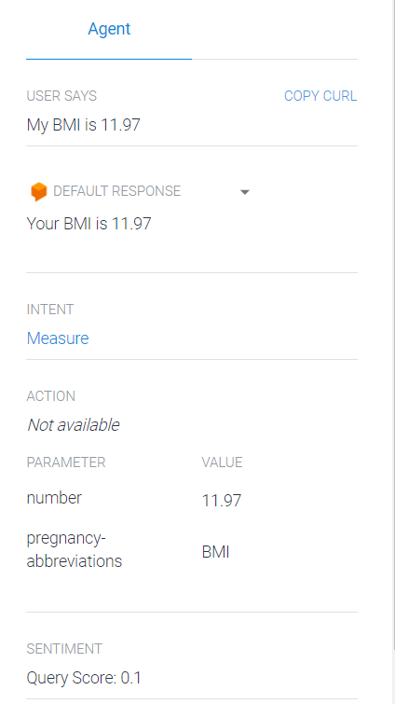

Figure17-Extracting Parameters on Simulator

In the simulator, enter My bp is 11.97.

You can see that Dialogflow correctly extracted bp for the pregnancy-abbreviations parameter, identified it as the Blood Pressure entity, and inserted the value in the response.

## Contexts

To control the flow of the conversation, you can use context.

### Add a follow-up intent

Follow-up intents provide a simple way to control a conversation without having to create and manage contexts manually.

When you create a follow-up intent, an output context is added to the parent intent and an input context of the same name is added to the child intent. This means that the follow-up intent is matched only when the parent intent is matched in the previous conversational turn.

Add a custom follow-up intent to the measure intent:

1. Select the measure intent you created in the previous steps.
2. In the **Response** section, update the text response:
   * Wow! That’s great. Could you help me with your $age?
3. Click the **Save** button and wait until the **Agent Training** dialog indicates that training is complete.
4. Click **Intents** in the left sidebar menu.
5. Hover over the measure intent and click **Add follow-up intent**.
6. Click **custom** in the revealed list.
7. Click the **Save** button and wait until the **Agent Training** dialog indicates that training is complete.

Dialogflow automatically names the follow-up intent measure - custom.

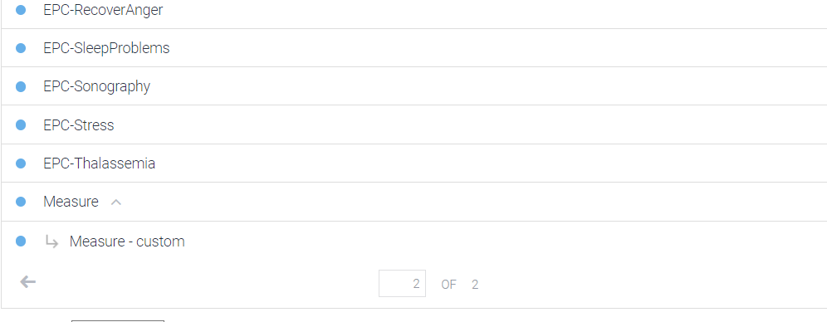

### Figure18- Custom Intents

### Intent matching with follow-up intents

Follow-up intents are only matched after the parent intent has been matched. Since the measure - custom intent is only matched after the measure intent, you can assume that the user has just been asked the question what is a good $pregnancy-abbreviations? Now you can add training phrases for likely user answers to that question:

1. Click **Intents** in the left sidebar menu.
2. Click the measure - custom intent.
3. Add the following training phrases:
   * 8 - 12
4. Click the **Save** button and wait until the **Agent Training** dialog indicates that training is complete.

### Test your follow-up intent

### Enter My bp is 11.8 in the simulator, then answer the question Wow! That’s great. Could you help me with your $age? with about 21 years.

Despite there being no response for the second expression (about 21 years), you can see the expression is matched to the correct intent (measure - custom), and the duration parameter is correctly parsed (21 years).

### Intents and contexts

Inspect the measure intent to see that measure-followup is listed as an output context and is prefaced by the number 2. This number is called the [lifespan](https://cloud.google.com/dialogflow/docs/contexts-input-output#lifespan).

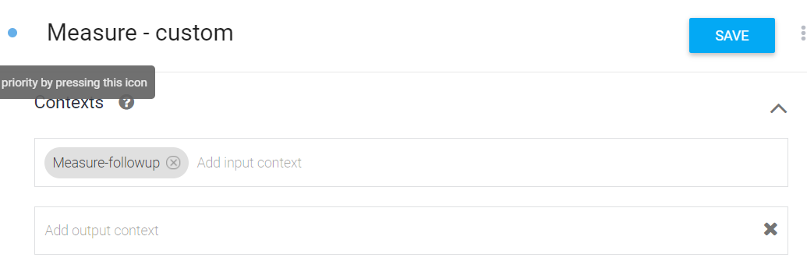

Figure19- Custom Intent Context

After the measure intent is matched, the measure - followup context is active and attached to the conversation for two turns (lifespan of 2). Therefore, when the user responds to the question, Wow! That’s great. Could you help me with your $age? the measure-followup context is active.

Inspect the measure - custom intent to see that measure - followup is listed as an input context, which is the same as the output context for the measure intent.

Any intents with an input context that matches an active context are heavily favored when Dialogflow matches intents.

### Contexts and parameters

Contexts store parameter values, and you can access the values of parameters defined in the measure intent when its output context is active.

In the measure - custom intent, you only asked for the duration the user has known the language, and not the referenced language itself.

To reference the language in the response:

1. Update the measure - custom intent text response to I can't believe your #measure-followup.pregnancyabbreviations is $number!
2. Click the **Save** button and wait until the **Agent Training** dialog indicates that training is complete.

The #measure-followup.pregnancyabbreviations reference is known as a parameter reference for an active context.

### Test the context parameter

Enter my bp is 11.8 in the simulator, and then respond to the question with 21 years. Notice that the pregnancy-abbreviations parameter value is retrieved from the context.

1. **Intents are created.**

To answer each types of module. Intent related to that module is created.

1. In the **Intent name** field, topics is typed.
2. **Parameters and Action are added**.
3. In the **Enter action name** field, lookup is typed.
4. The following is entered in the Parameters table
   * In the **Parameter Name** field, topic.
   * In the **Entity** field, @Topic.
   * In the **Value** field, $topic.

The following would create a lookup action passing the topic parameter to the webhook and hence retrieving information.

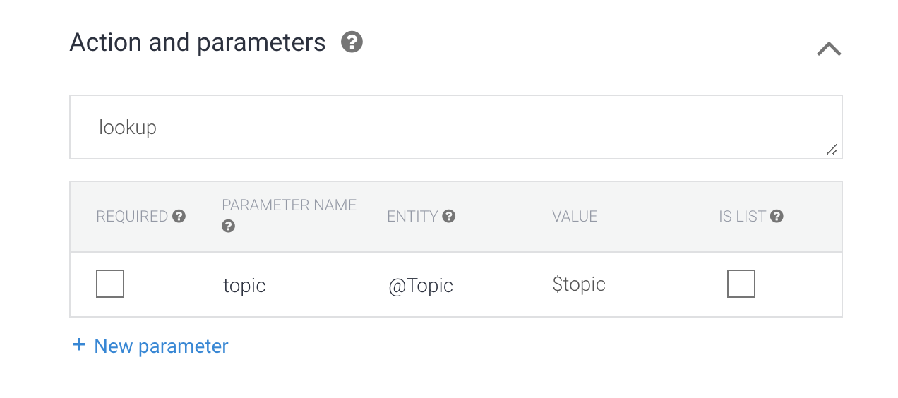 Figure20- Lookup Action

### Train a chatbot Intent.

1. Now the next step was to train the created intents by adding the training phrases with the following steps:
   1. In the **Add user expression** field, I'd like to know about the importance of discipline in pregnancy.
   2. Select the word **discipline**.

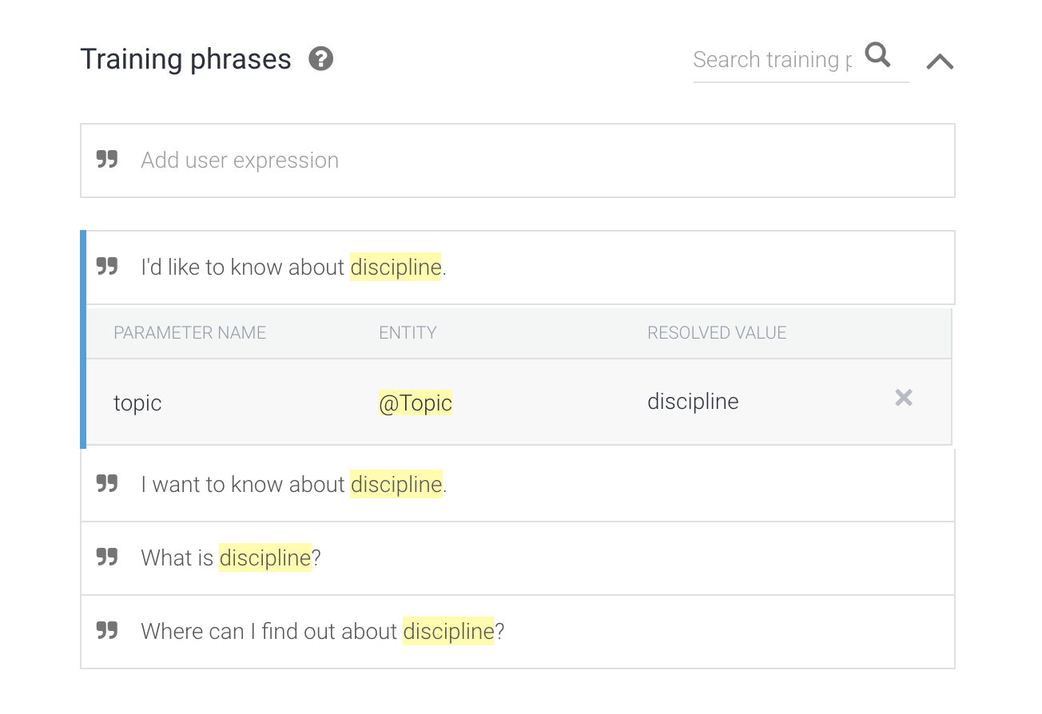

Figure21- Resolving values in training phrases.

* 1. In the dialog, **@Topic: topic** informs Dialogflow where it must extract the topic parameter exactly from.

Dialogflow now trains the agent based on the example intentions. The training gets completed with a notification message pop-up.

### Test your chatbot.

* In the Dialogflow console, inside the input field, the sample questions are typed in different grammatical forms. This displays a response from the Virtual assistant.

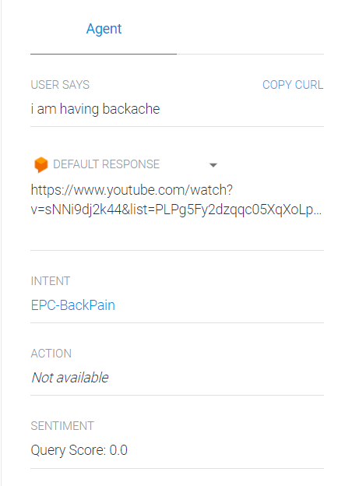

Figure22- Chatbot Testing

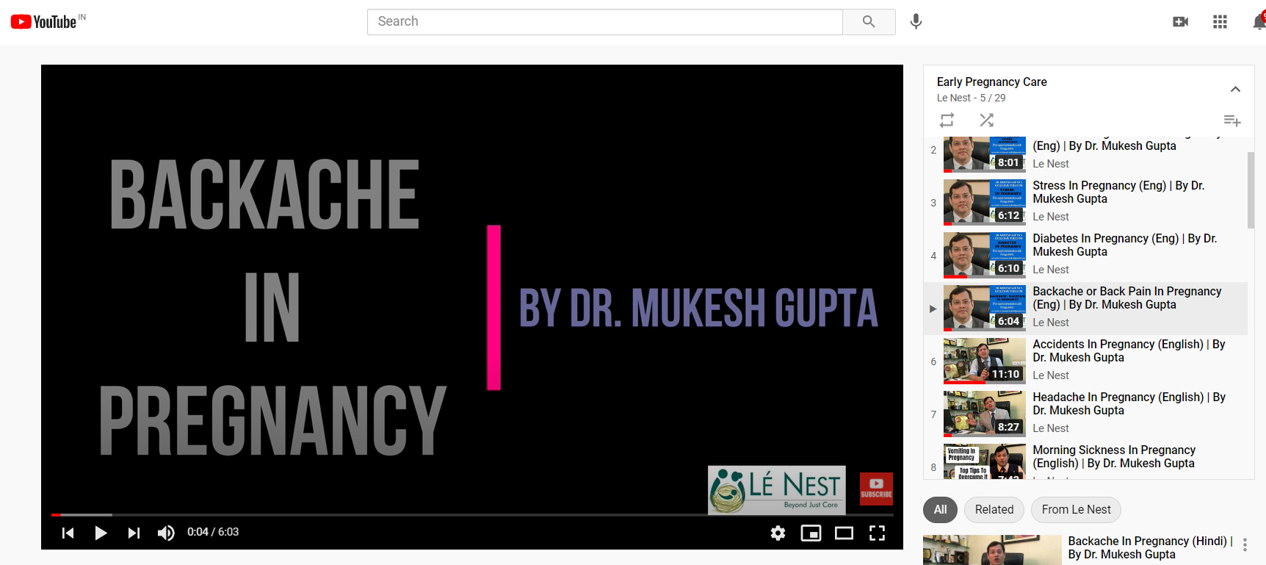

## Figure23- Response Video

## **Training and testing the chatbot**

After having all the training data of the chatbot. Intent creation was used that could take the queries that the pregnant mothers may ask the virtual assistant. Then, we tested the chatbot using Dialogflow’s built-in simulator.

### The built chatbot needs to be integrated with a platform to make it universally accessible to each user. To achieve this Dialogflow Messenger integration is used. A Facebook messenger bot is created to interact with the end-users. Therefore, with the help of Dialogflow Facebook Messenger integration, A Facebook Messenger bot to interact with the end-users is created.

### The overview of the integration is that a Facebook app is created using the Messenger Platform and configured with Dialogflow for communication then the Dialogflow integration uses the Facebook API for sending messages which get received from the end-user through the Dialogflow integration with Facebook Messenger webhook. The code which powers this experience is open-source and helps businesses to start delivering a great messaging experience. This will enable to automation of the responses from the server and keep the page engaged.

## These are the following requirements needed for deploying the Messenger app

* **There needs to be a Facebook page representing the business identity and connecting to the people on Messenger.**
* **A Facebook Developer Account** is needed for creating new apps that are the core of Integration provided by Facebook. Facebook Developers website can be used to get started on this.
* A Facebook app containing the setting for the app including the access tokens is needed for creating a new app by visiting the Facebook developers webpage.

For Creating a Facebook Page

* Make a Facebook account and log into the account. Create a page by giving out the required category and name and thus, creating a test page. 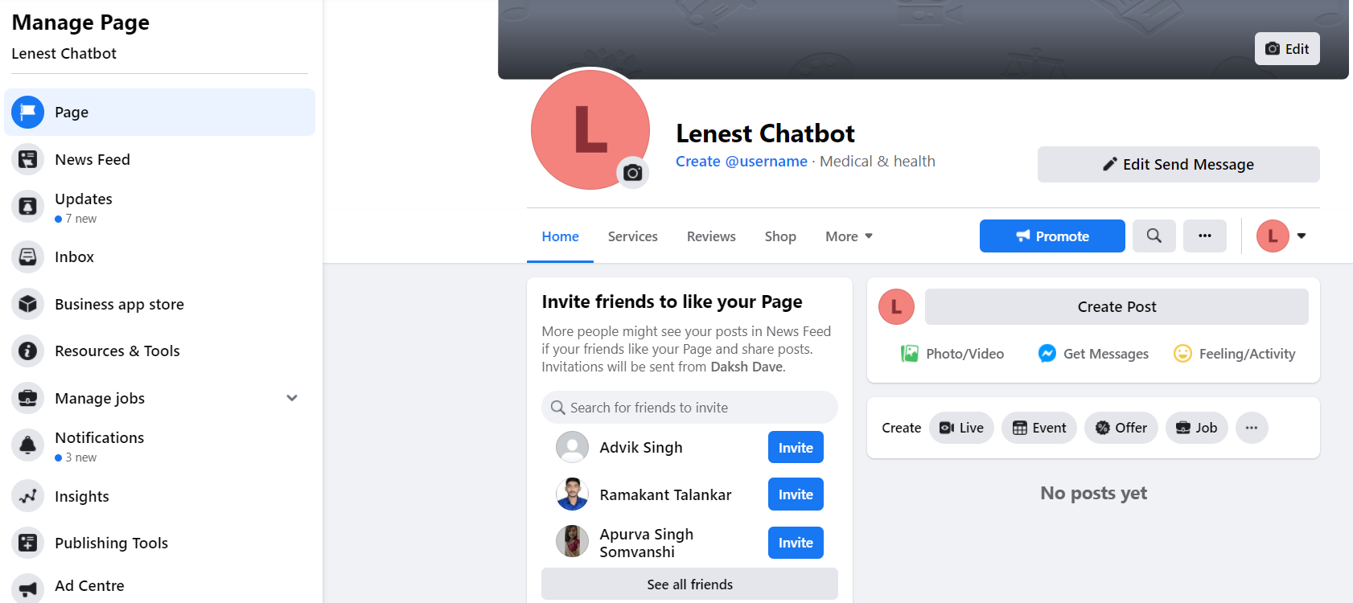

Figure24- Created Facebook Page

* Add the messenger button on Facebook named **Send Message**.
* The button added opens up the messenger chat. However, doesn’t reply to the messages as the Dialogflow agent has not been integrated.

**APP creation in Facebook Developer Account**

* Register as a Facebook developer and create an app by visiting the create new app page on the Facebook Developer webpage.

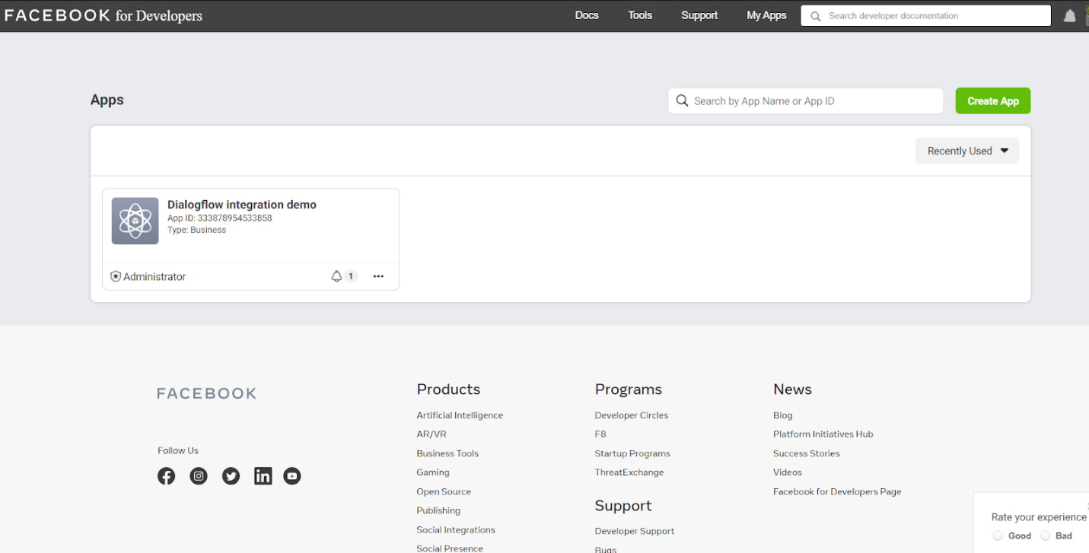

Figure25- App Page

* Click on **Create App** button.

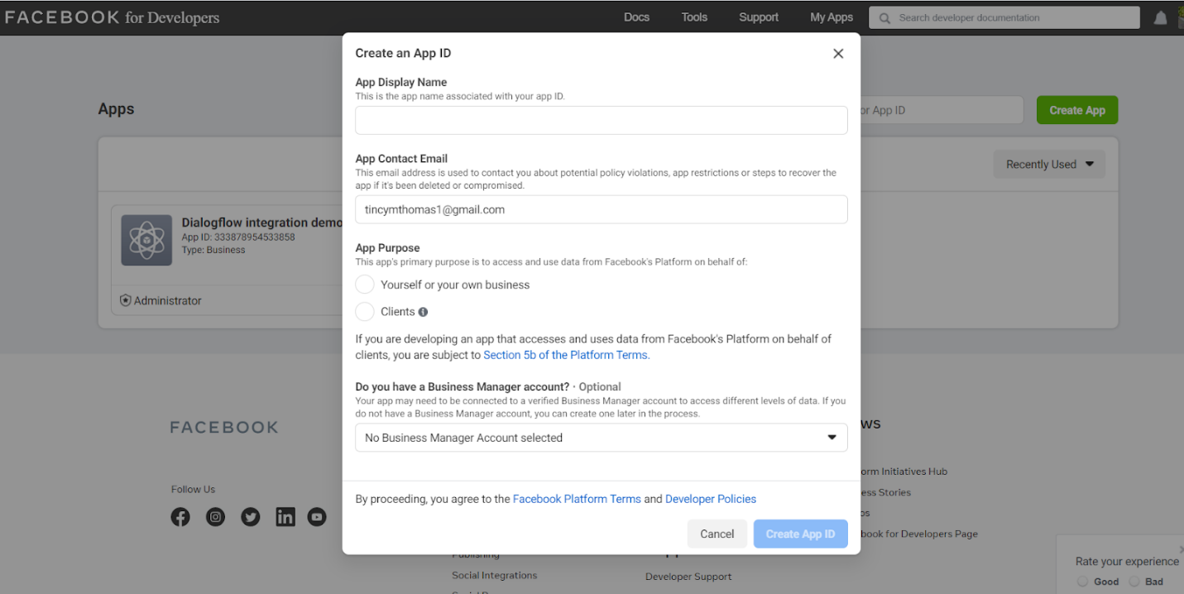

Figure26- Create an App

* Lenest Chatbot app name is selected, and email id is filled. The procedure gets finished by a security check. The app is created.
* 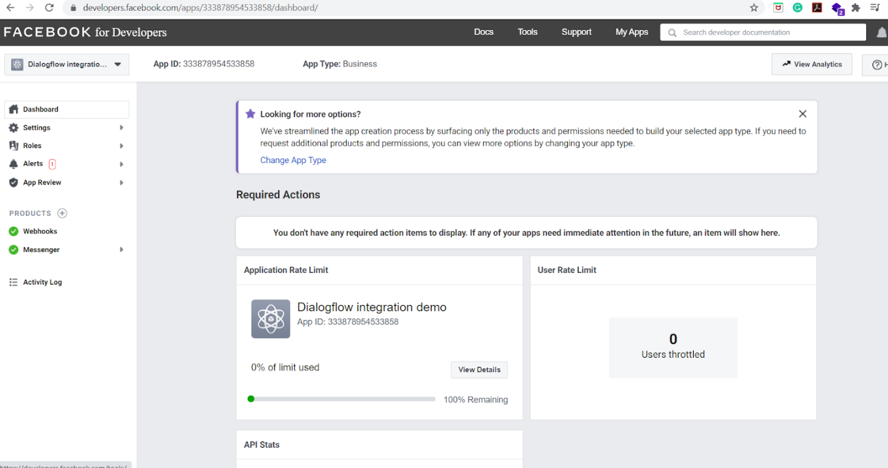

Figure27- The Created App

The Dialogflow agent is used to connect it with the Facebook App.

**Dialogflow-Messenger Integration**

* To setup, the messenger click on the products

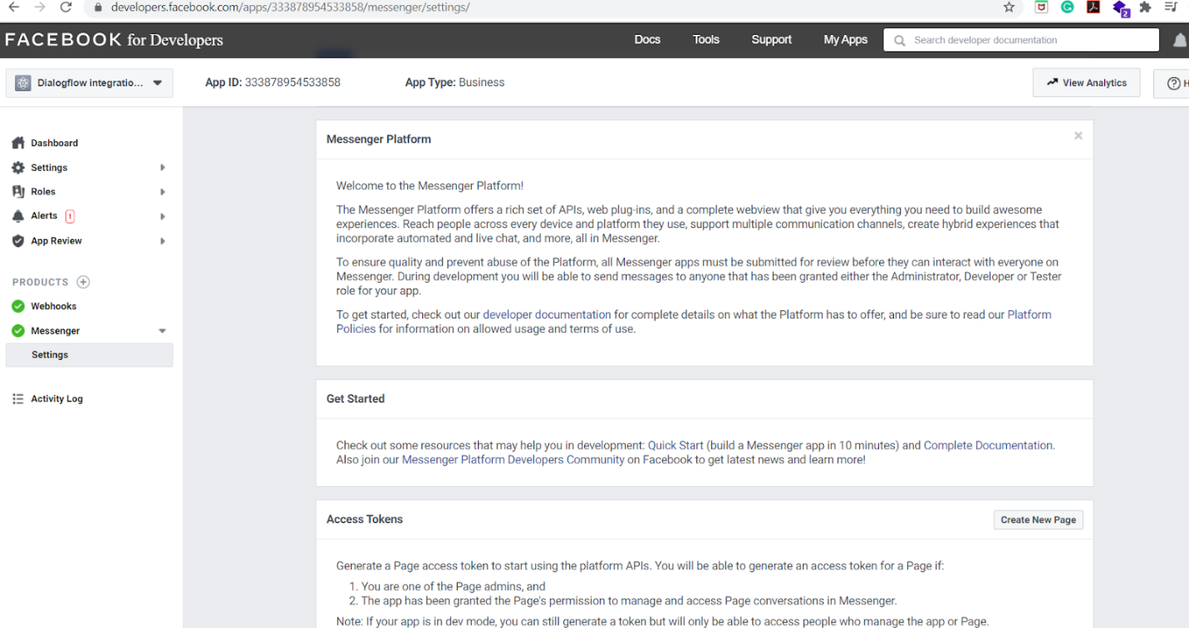

Figure28- Messenger Platform Intgeration Settings

* On the page click the Setup Messenger Button. After this visit the Dialogflow agent by clicking on the integrations button and clicking the Messenger from Facebook.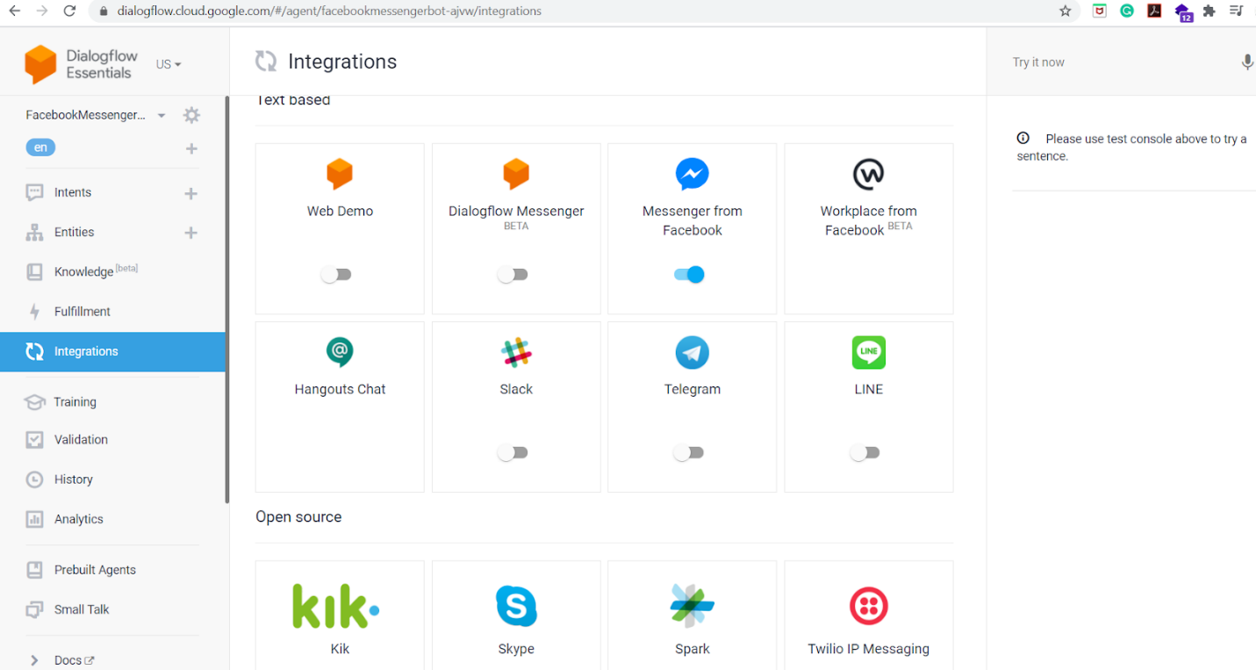

Figure29- Dialogflow Integrations

* The button will redirect to the page shown below that mentions the steps to fill it up.

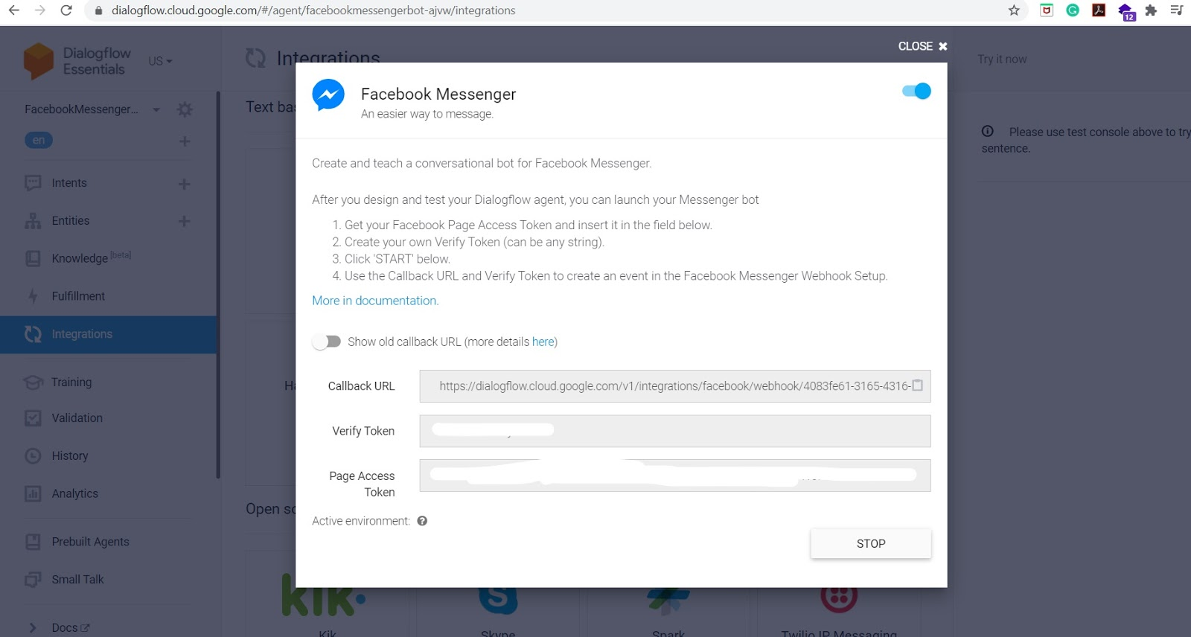

Figure30- Dialogflow to Messenger Integration

From the Dialogflow console, the integration gets configured.

* + Dialogflow ES console is visited.
  + Integration is selected in the left sidebar.
  + Select Facebook Messenger.
  + Configuration Dialog opens:
    - **Integration toggle is selected at the top of the dialog for enabling the integration**.
    - There is also an old callback URL that is shown defaults to off as a temporary option for accommodating the recent modification to the API of Facebook Messenger. The option gets removed after all the agents are updated.
    - **A** callback URL is provided that is copied for configuring in the Facebook messenger webhook.
    - Any desired private token can be entered and copied to configure the Facebook Messenger Webhook.
    - The copied token is known as the Page access token and is copied when the Facebook page is created.
    - Click to start this integration service for your agent.
* Using the Facebook developer account, the page access token of the Facebook page is obtained. Any name can be given to the Verify token field by providing a secure name. The bot then gets started after clicking on the start button.
* Redirect to the webhooks section in the Facebook Developer’s account and copy the Verify token along with the callback URL from the Dialogflow agent and pasting that into the Facebook Developer’s account.
* Tick the messaging\_postbacks and messages checkbox and click verify and save.
* In the webhooks section select the Facebook Page to integrate with Dialogflow and click on the subscribe button to connect the agent with the FB Page.

In the Facebook Page test the Chatbot

* View the Facebook page as Page Visitor. It is found that the chatbot is not publicly accessible. Only the admins and app creators can chat with the bot. The app needs to be published to make it accessible to everyone.
* Click the send message button and click on the test button. Then test by chatting on the specified intents pre-feed into the Dialogflow agent. 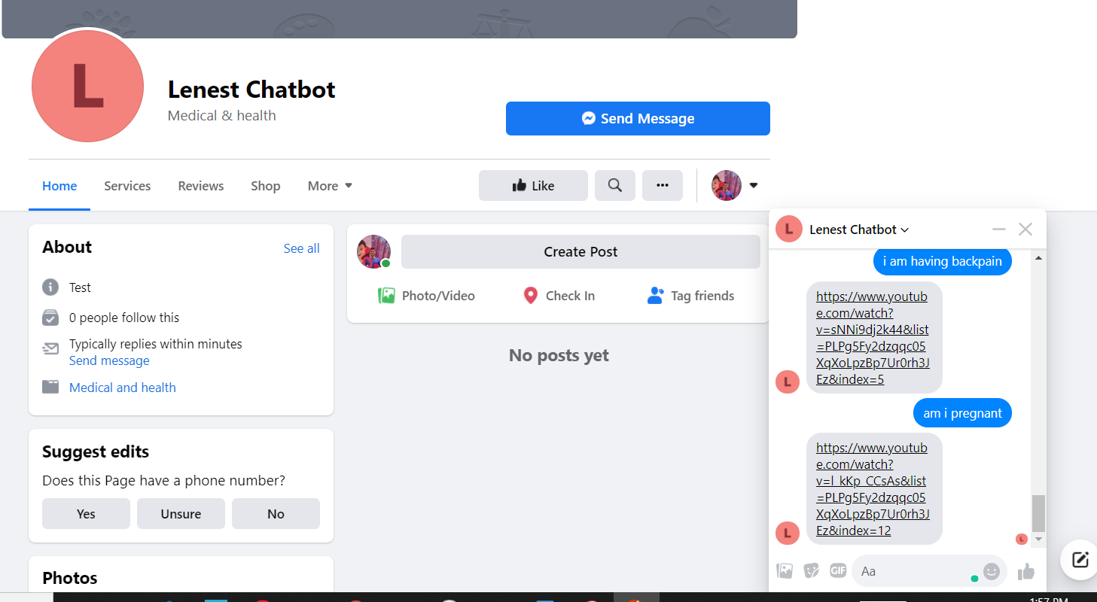

Figure31- Dialogflow Integrated Facebook Page

This completes the process of integrating the Facebook chatbot with the Dialogflow agent. Further, a test page along with an app is created for testing and getting a hands-on experience with Messenger. The app is ready to be deployed and gets submitted for the review process. The app gets ready to interact with the public once the review process is passed.

**Website Integration**

Now we need to integrate the agent with the website. The website named <https://lenest.in/> is already up and running. There are 2 ways this Dialogflow can be displayed on the agent:

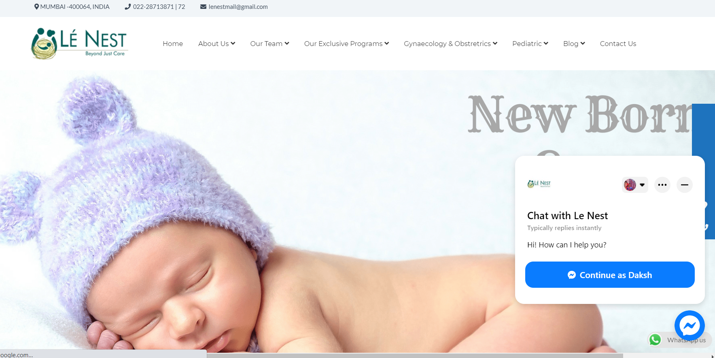

Figure32- LeNest Webpage

1. By directly adding the Facebook messenger bot built on the Lenest Chatbot Facebook page.

2. Going to the integrations in the Dialogflow console and then turning on the Dialogflow Messenger option.

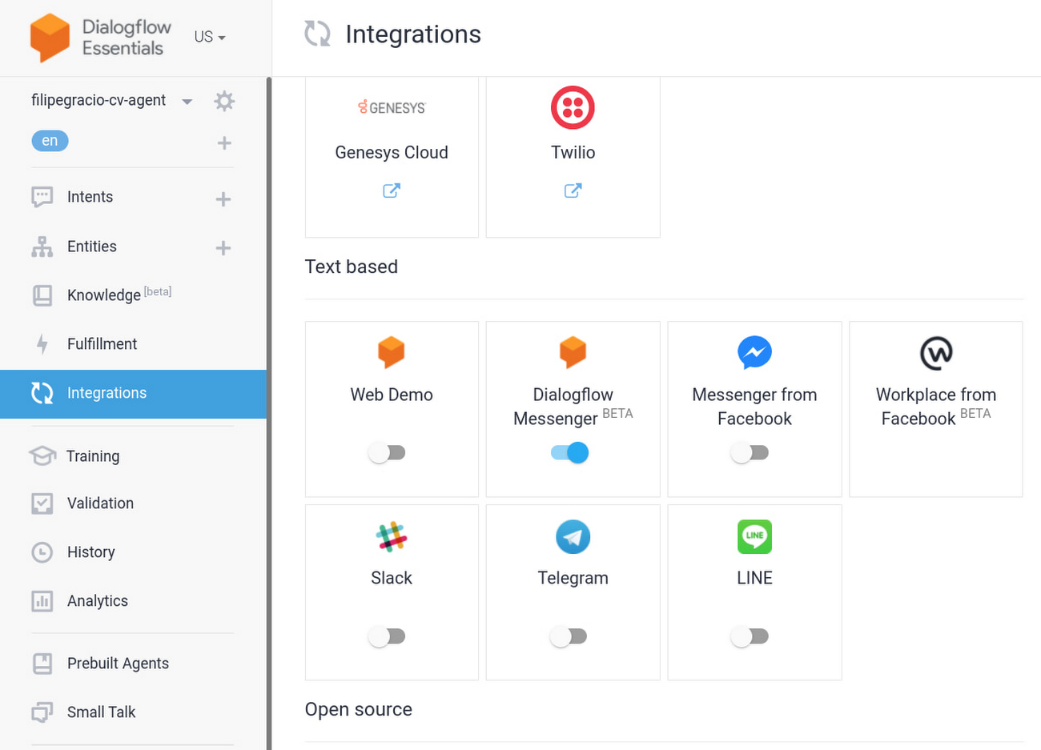

Figure33- Dialogflow Messenger Integration

Clicking on that enables a window containing a piece of code that needs to be embedded into the original website code. The following is the piece of code that is obtained:

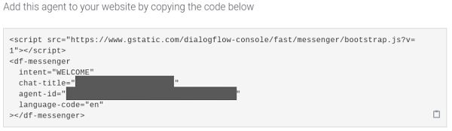 Figure34- Agent code

The code is copied onto the clipboard.

8. The next step involves just putting up the agent on the site. The original code of the website needs to be embedded from the console of Dialogflow.

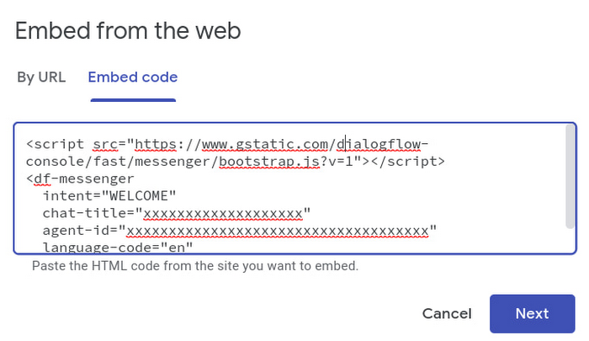 Figure35- Embedded Agent Code

Now, the Website is ready to be published and made public with the agent ready to answer all the questions asked by the visitors.

### The following training tools were used at different development stages

To refine the training at each stage, Use the Training Tool at various stages of agent development, and refine your training data at each stage:

* Before releasing the agent, it is tested on a small user group.
* After production, the conversations are closely examined to make sure the agent is robust.
* New updates made after production are closely observed.
* A regular analysis is performed by running the tool periodically

### We update the agent intents through the Import of quality data.

Some useful data sources used for importing quality data are as follows:

* Conversation logs with humans
* Conversation logs of customer support through online mode like email, forums, FAQs, etc.
* Questions asked by the patients on social media.

The following types of data are avoided.

* Long non-conversational expressions.
* Irrelevant user expressions not related to any of the intents.
* Logs that are considering the end-user responses.

## **Challenges & Limitations of Bots/Study**

Chatbots are yet to be fully explored and are at a very basic developmental phase. The chatbots have deep-strong connected roots to Machine Learning, Deep Learning, and Artificial Intelligence hence there are several challenges that these bots face.

### Complex Interface

There can be instances when a specific query matches multiple queries leading to the chatbot getting confused leading to extra consumption of time. There needs to be proper database management with robust architecture for handling multiple users at an instance.

### Time-Consuming Scenarios

Generally, the user expects a quick reply from the chatbot however at times the right keyword is not found and the chatbot doesn’t know what to reply so tries matching all the intents which is a time-consuming process. This delay aggravates when the system has a lot of users leading to a bad user experience.

### High Installation Cost

Designing and developing a chatbot requires skilled expertise and a lot of manpower with constant changes/updates in the front-end and back-end functionalities. As the users increase so does the cost to manage the data and endure the smooth running of the server increases to prevent concurrency issues.

### Less Decision-Making Skills

The chatbots are not extremely reliable in processes involving important decision-making. The architectures need to be more robustly built artificial intelligence instilled in the chatbots to make unbiased gender-neutral decisions and ensure fairness to everyone.

### Weak Memory Storage and Processing

The user history accessibility to chatbots is a challenge as that requires a huge amount of data storage space for thousands of users to avoid sending redundant questions and answers. Previous chat data enhances the user experience and helps give them a personalized assistant feeling. This would also enable the chatbot to make more customized suggestions and recommendations to the users.

**Benefits**

Chatbots require less manpower to operate when outsourced through an agency and serve as an important tool for E-commerce companies, Customer Support Agents, Online Marketing, and more. Chatbots are an important component in building good customer relationships. Nowadays, chatbots find great engagement rates in website pages and social media handles. The tool comes in handy while scaling businesses and analyzing the customer trends or requirements through chatbot conversations.

The following are the chatbot benefits:

* *Social Media Presence*
* *Quick response time*
* *Easy reach out*
* *Better engagement*
* *Personalized Experience*
* *Gather & analyze customer data*
* *Lead nurturing*

The chatbot supports an Omnichannel network. After a basic foundational network is built it can be deployed anywhere by seamlessly integrating across any of the digital channels and platforms. The end-to-end management system presents all the experiments, analytics, and evaluation without the requirement of custom software.

These bots interact accurately and naturally with the user thus, providing better customer experiences, in turn, improving patient value, adherence, and engagement. These bots are secure and provide constant virtual care to the patient. The data points generated are very useful in providing insights to the doctors through healthcare analytics. The operational data across the systems help the healthcare providers in making effective and confident decisions.

**Improvements/Innovation/Future Scope of work**

The application promises huge future prospects in updating and scalability. Modifying and capturing appropriate data points like geographic site locations, patient directions from the customers can help modernize the patient-facing applications. The chatbot can be used to rack and integrate all the stakeholders that include the customers, partners, patients, and employees in the process of research studies and clinical trials. The application can easily be updated to accelerate the process of drug development by gathering the medical research data to enroll, engage and recruit participants directly through the application and keep track of their health along with specialized analytics through the data points.

Further, Virtual assistants also known as chatbots have hugely contributed to the digital world market A research [8] states, “*there are nearly 5.19 billion unique smartphone users, 4.54 billion internet users via smartphones and 3.80 billion users actively using social media. On average every internet user spends around six to seven hours online on daily basis.*” The increasing count of people switching and engaging on online platforms acts as an important tool for connecting the customers to businesses. Almost every small or big firm is using Digital Platforms to stay connected to their customers in a better way and increase the customer-to-company pre and post-sales engagement time. As the markets keep expanding and new players venture out into the market. The need for a virtual assistant would keep on expanding exponentially.

The main challenge currently encountered by mathematicians, companies, scientists, and developers is to make the chatbot more engaging and to keep the conversations helpful without providing an unrelated response on encountering a new or a random query. The vision is to empower the bot into a personal assistant that can sense the need of the user to build human-like intelligence, experiences, and abilities. The next big challenge lies in ensuring that the privacy and data of the user remain intact. The extracted data should be used only to improve the user experience. The chatbots that we have developed are not just limited to a particular sector for a particular set of usage but can be scaled to other fields as well. The Deep Tech and Natural Language Processing technologies are still in their developmental stages to be implemented on a much larger universal scale and it would take a few years to come with a robust assistant that acts as a human-like personal assistant.

**Conclusions**

The progress made by the present research work and development enterprises looks promising and can only improve our faith in the technology. The future for chatbot technology is heading towards its adoption in almost every small to large scale business. This paper discussed the pipelining and workflow of the code, intent formulation and matching, training, and testing the model to get the necessary output. The paper also presented the existing literature and research proceedings in this domain along with its industrial applications, challenges, and limitations to this technology.

Healthcare is one of the most important domains that would be impacted and greatly benefitted by the growth of technology. The proposed application solution would help the healthcare providers better understand the problems that are being faced by them and identify and rectify the loopholes in the value chain of booking an appointment to getting cured with the help of a personalized Virtual Doctor that would help hospitals in reducing the hassles of handling patients. By deploying this chatbot the hospitals, as well as other stakeholders, can immensely benefit through a positive behavioral change. The adoption of a well-trained chatbot would prove to be the number one priority for all organizations in the near future.

References:

*1. Kandpal, P., Jasnani, K., Raut, R., & Bhorge, S. (2020). Contextual Chatbot for Healthcare Purposes (using Deep Learning). 2020 Fourth World Conference on Smart Trends in Systems, Security and Sustainability (WorldS4), 625–634.*

*2. Gelfenbeyn, I., Goncharuk, A., & Sirotin, P. (2018, April 17). Dialogflow ES DOCUMENTATION | Google Cloud.*

*3. Siddig, A., & Hines, A. (n.d.). A Psychologist Chatbot Developing Experience. 12.*

*4. Bahja, M., Hammad, R., & Butt, G. (2020). A User-Centric Framework for Educational Chatbots Design and Development (pp. 32–43).*

*5. Ivanovic M and Semnic M. The Role of Agent Technologies in Personalized Medicine. In: 2018 5th*

*International Conference on Systems and Informatics (ICSAI), 2018, IEEE, pp.299–304.*

*6. Hoermann S, McCabe KL, Milne DN, et al. Application of synchronous text-based dialogue systems in mental health interventions: Systematic review. J Med Internet Res 2017; 19(8): e267.*

*7. Fadhil A and Gabrielli S. Addressing challenges in promoting healthy lifestyles: the al-chatbot approach. In: Proceedings of the 11th EAI International Conference on Pervasive Computing Technologies for Healthcare, ACM, 2017, pp.261–265.*

*8. Comendador BEV, Francisco BMB, Medenilla JS, et al. Pharmabot: A pediatric generic medicine consultant chatbot. J Automat Control Eng 2015; 3(2): 137–140. 9. Abashev A, Grigoryev R, Grigorian K, et al. Programming tools for messenger-based chatbot system organization: Implication for outpatient and translational medicines. BioNanoScience 2017; 7(2): 403–407.*

*9. Nadarzynski, T., Miles, O., Cowie, A., & Ridge, D. (2019). Acceptability of artificial intelligence (AI)-led chatbot services in healthcare: A mixed-methods study. Digital Health, 5.*

*10. Harwich E and Laycock K (2018). Thinking on its Own—AI in the NHS. (Reform).*

*11. Shangrapawar, A., Ravekar, A., Kale, S., Kumari, N., & Shende, A. (2020). Artificial Intelligence based Healthcare Chatbot System. 07(02), 3.*

*12. Rarhi, K., Bhattacharya, A., Mishra, A., & Mandal, K. (2017). Automated Medical Chatbot. SSRN Electronic Journal.*

*13. Srivastava, P., & Singh, N. (2020). Automatized Medical Chatbot (Medibot). 2020 International Conference on Power Electronics IoT Applications in Renewable Energy and Its Control (PARC), 351–354.*

*14. Wang, L., Wang, D., Tian, F., Peng, Z., Fan, X., Zhang, Z., Ma, S., Yu, M., Ma, X., & Wang, H. (2021). CASS: Towards Building a Social-Support Chatbot for Online Health Community. ArXiv:2101.01583 [Cs].*

*15. Mathew, R. B., Varghese, S., Joy, S. E., & Alex, S. S. (2019). Chatbot for Disease Prediction and Treatment Recommendation using Machine Learning. 2019 3rd International Conference on Trends in Electronics and Informatics (ICOEI), 851–856.*

*16. Intelligent Chatbot for Medical Assistance in Rural Areas. (2020). International Journal of Innovative Technology and Exploring Engineering, 9(6), 24–31.*

*17. Vaira, L., Bochicchio, M. A., Conte, M., Casaluci, F. M., & Melpignano, A. (2018). MamaBot: A System based on ML and NLP for supporting Women and Families during Pregnancy. Proceedings of the 22nd International Database Engineering & Applications Symposium on - IDEAS 2018, 273–277.*

*18. Kumar, S. A., Krishna, C. V., Reddy, P. N., Reddy, B. R. K., & Jacob, I. J. (2020). Self-Diagnosing Health Care Chatbot using Machine Learning. International Journal of Advanced Science and Technology, 29(05), 9323–9330.*

*19. Mugoye, K., Okoyo, H., & Mcoyowo, S. (2019). Smart-bot Technology: Conversational Agents Role in Maternal Healthcare Support. 2019 IST-Africa Week Conference (IST-Africa), 1–7.*

*20. Omoregbe, N. A. I., Ndaman, I. O., Misra, S., Abayomi-Alli, O. O., & Damaševičius, R. (2020, September 29). Text Messaging-Based Medical Diagnosis Using Natural Language Processing and Fuzzy Logic [Research Article]. Journal of Healthcare Engineering; Hindawi.*